**UMUC StateBirdFlower Test Plan**

Files: StateBirdFlower.java, Test StateBirdFlower.java

Author: John Bernat

Date: 11Dec2016

**Description:**

This program creates StateBirdFlower class and assigns various attributes to objects using information from a multidimensional array containing the state name, state bird, and state flower. The test cases takes user input and assign input values as parameters when creating objects and adjusts some of the values and retrieves them for output.

**Test Case 1: maryland**

|  |  |  |  |  |
| --- | --- | --- | --- | --- |
| Parameter | Input | Expected Output | Actual Output | Pass/Fail |
| State (user input) | maryland | maryland | maryland | Pass |
| bird | None (default) | Baltimore Oriole | Baltimore Oriole | Pass |
| flower | None (default) | Black-Eyed Susan | Black-Eyed Susan | Pass |
| toString | None (default) | The state bird for maryland is the Baltimore Oriole and the state flower for maryland is the Black-Eyed Susan. | The state bird for maryland is the Baltimore Oriole and the state flower for maryland is the Black-Eyed Susan. | Pass |

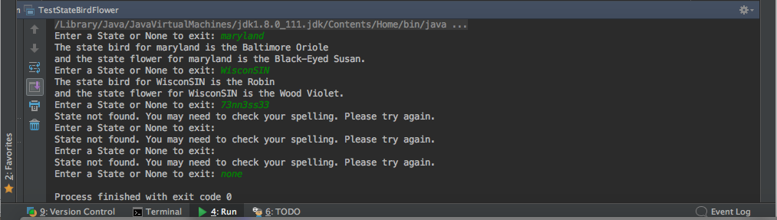

**Test Case 2: WisconSIN**

|  |  |  |  |  |
| --- | --- | --- | --- | --- |
| Parameter | Input | Expected Output | Actual Output | Pass/Fail |
| State (user input) | WinsconSIN | WinsconSIN | WinsconSIN | Pass |
| bird | None (default) | Robin | Robin | Pass |
| flower | None (default) | Wood Violet | Wood Violet | Pass |
| toString | None (default) | The state bird for WisconSIN is the Robin and the state flower for WisconSIN is the Wood Violet. | The state bird for WisconSIN is the Robin and the state flower for WisconSIN is the Wood Violet. | Pass |



**Test Case 3: 73nn3ss33 (leet speak)**

|  |  |  |  |  |
| --- | --- | --- | --- | --- |
| Parameter | Input | Expected Output | Actual Output | Pass/Fail |
| State (user input) | 73nn3ss33 | None | none | Pass |
| bird | None (default) | null | null | Pass |
| flower | None (default) | null | null | Pass |
| Other | None (default) | State not found. You may need to check your spelling. Please try again. | State not found. You may need to check your spelling. Please try again. | Pass |
| toString | None (default) | none | none | Pass |



**Test Case 4: (blank)**

|  |  |  |  |  |
| --- | --- | --- | --- | --- |
| Parameter | Input | Expected Output | Actual Output | Pass/Fail |
| State (user input) | (blank) |  |  | Pass |
| bird | None (default) |  |  | Pass |
| flower | None (default) |  |  | Pass |
| Other | None (default) | State not found. You may need to check your spelling. Please try again. | State not found. You may need to check your spelling. Please try again. | Pass |
| toString | None (default) |  |  | Pass |



**Test Case 5: none**

|  |  |  |  |  |
| --- | --- | --- | --- | --- |
| Parameter | Input | Expected Output | Actual Output | Pass/Fail |
| State (user input) | none |  |  | Pass |
| bird | None (default) |  |  | Pass |
| flower | None (default) |  |  | Pass |
| Other | None (default) | None (system will exit with error code 0) | None (system exited with error code 0) | Pass |
| toString | None (default) |  |  | Pass |

